TC-CSC-009
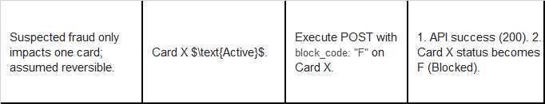
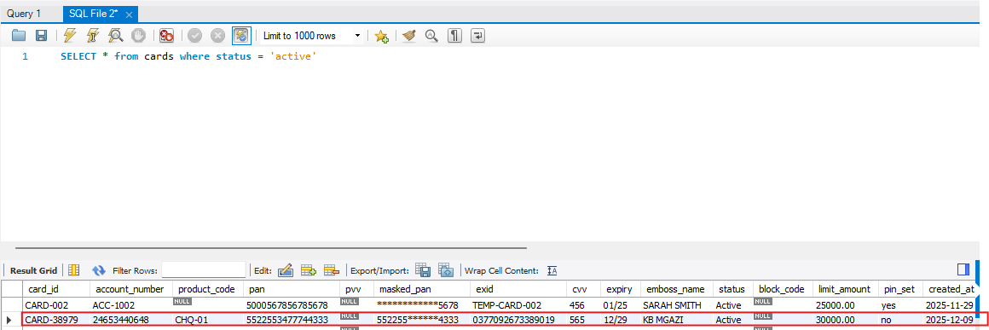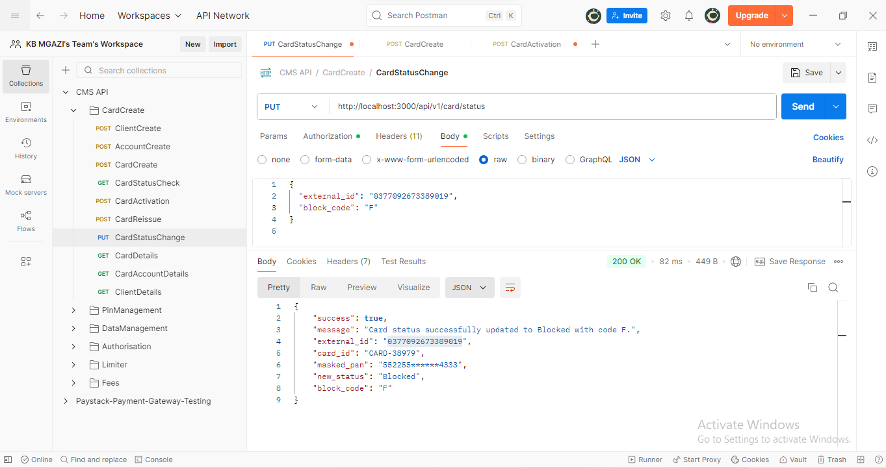
Request:
{
"external_id": "0377092673389019",
"block_code": "F"
}

Response:
{
"success": true,
"message": "Card status successfully updated to Blocked with code F.",
"external_id": "0377092673389019",
"card_id": "CARD-38979",
"masked_pan": "552255******4333",
"new_status": "Blocked",
"block_code": "F"
}

